

**MIDDLE EAST TECHNICAL UNIVERSITY**

**DEPARTMENT OF ELECTRICAL & ELECTRONICS ENGINEERING**

**EE 464- Hardware Project – 2023 Spring**

**Simulation Report**

**Isolated DC-DC Battery Charger**

**Peaky Converters**

Çağlar Umut Özten

Onur Toprak

# Introduction

Due to a variety of applications, including portable electronics and renewable energy systems, there is a constant need in modern power electronics for DC-DC converters that are dependable and efficient. The goal of this project is to design and build an isolated DC-DC converter that satisfies tight requirements for power efficiency, output voltage stability, and input voltage range.   
  
 This converter's goal is to convert an input voltage between 20 and 40 volts into a steady 12 volt output with a maximum power output of 60 watts. Additionally, the converter must have outstanding line and load regulation, with variances of no more than 3% across a range of input voltages and load circumstances, and the output voltage ripple should be kept to a maximum of 3%.

## Key Project Requirements:

**Closed-Loop Control:** A closed-loop control system is essential for maintaining precise regulation of the output voltage under changing input and load conditions. This ensures stability and reliability in various operating scenarios.

**Self-Powered Control Circuits:** The project restricts the use of external power supplies for control circuits, emphasizing the need for a self-powered solution that derives its operational energy from the main power source.

**Magnetic Design:** The magnetic design for the isolated DC-DC converter is a critical aspect that directly impacts performance, efficiency, and size of the converter. The key components requiring careful magnetic design include transformers and inductors.

## Additional Objectives:

Beyond meeting the basic specifications, additional project goals may involve enhancing the converter's efficiency, achieving a compact design, and exploring advanced techniques like soft switching to minimize switching losses and improve overall performance.

## Challenges and Opportunities:

Designing an efficient isolated DC-DC converter requires addressing challenges related to component selection, circuit layout, magnetic design (transformers and inductors), and control strategy. Balancing performance with factors like cost, size, and complexity presents opportunities for innovation and optimization throughout the design process.

Throughout this report, procedure of the DC-DC Isolated Converter will be explained. Step by step, examination of the topology selection, magnetic design and controller will be carried. After checking results with simulations, component selection and further consideratioons will be done.

# Topology Selection

## Flyback Converter:

diyagram, metin, teknik çizim, plan içeren bir resim

Açıklama otomatik olarak oluşturuldu

The flyback converter is a type of isolated DC-DC converter that stores energy in the transformer during the ON time of the switching cycle and releases it to the output during the OFF time. Here's a simplified explanation of how it works:

**Operation:** During the ON time of the switching cycle, the primary winding of the transformer is energized, storing energy in the magnetic field of the transformer core.

**Energy Transfer:** When the switch turns OFF, the magnetic field collapses, inducing a voltage in the secondary winding of the transformer. This voltage is rectified and filtered to provide the desired output voltage.

**Isolation:** The flyback converter provides galvanic isolation between the input and output through the transformer, making it suitable for applications requiring isolation such as in power supplies and converters.

**Advantages:** Simple topology, low component count, and capability of stepping up or stepping down the input voltage.

**Disadvantages:** Typically higher output ripple, lower efficiency compared to forward converters especially at higher power levels, and limited to lower power applications due to transformer size and losses.

## Forward Converter:

diyagram, metin, teknik çizim, plan içeren bir resim

Açıklama otomatik olarak oluşturuldu

The forward converter is another type of isolated DC-DC converter that transfers energy from the input to the output through a transformer during each switching cycle. Here's a brief overview of its operation:

**Operation:** The primary winding of the transformer is energized during the ON time of the switching cycle, transferring energy to the secondary winding.

**Energy Transfer:** Energy is transferred from the primary side to the secondary side of the transformer during each switching cycle, providing isolation and stepping up or stepping down the voltage depending on the transformer turns ratio.

**Continuous Energy Transfer:** Unlike the flyback converter, the forward converter operates with continuous energy transfer through the transformer, resulting in generally higher efficiency and lower output ripple.

**Advantages:** Higher efficiency, lower output ripple, and better regulation compared to flyback converters especially at higher power levels.

**Disadvantages:** More complex control circuitry, additional components such as freewheeling diodes and snubber circuits, and limited duty cycle due to transformer reset constraints.

diyagram, metin, plan, teknik çizim içeren bir resim

Açıklama otomatik olarak oluşturuldu

In summary, the choice between flyback and forward converter topologies depends on specific application requirements including power level, efficiency targets, output ripple tolerance, and design complexity considerations. Each topology has its advantages and disadvantages, making them suitable for different types of DC-DC conversion applications.

We selected Forward Converter Topology due to high regulation neccessity.

# Analytical Calculations



At the beginning, for the not saturated core and high core losses, duty cycle must be smaller than 0.5. Moreover, due to the non-idealities and some deviations, the most duty cycle value is taken as 0.45. After that, from the equation, 𝑉𝑜𝑢𝑡 = 𝑉𝑖𝑛 ∗ (𝑁2/𝑁1) ∗ 𝐷, required turns ratio at the 20 V input case is 1.33. After that, for simplicity and safety of the operation modes, turns ratio determined as 1.5. Then duty cycle is calculated for 40 V input voltage case. Value is calculated as 0.3. Finally, with the turn ratio is 1.5, required duty cycle at 20 V input voltage case calculated as the 0.4.

In conclusion, turns ratio determined as the 1.5 and duty cycle varies between 0.2 and 0.4.

# Magnetic Design

By following Infenion’s Forward Design Handout[(1)](https://www.mouser.com/pdfdocs/2-10.pdf);

$n_{1}> \frac{V_{i},\max{ * } Dmax * 1/{f_{S}}}{B_{sat} * { A}_{e}}$**(1)**

$$k_{fill}= \frac{Total copper Area}{Window Area} (2)$$

$L_{o}>(1-\frac{ V_{o} * n1}{V_{i} * n_{2}})* \frac{1}{∆i_{Lo}}$ $* V_{o}*\frac{1}{f_{s}} =96 µH$**(3)**

$ƞ =\frac{P_{o}}{P_{i}}$, ( 80%) $I_{pri,mean,on}=$ $\frac{P_{i}}{V_{i }D}$ = **9.375 A** **(4)**

**(5)**

**(6)**

**(7)**

+ **(8)**

metin, yazı tipi, çizgi, diyagram içeren bir resim

Açıklama otomatik olarak oluşturuldu **(9)**

* Consideration of Toroidal Core;

metin, ekran görüntüsü, çizgi, sayı, numara içeren bir resim

Açıklama otomatik olarak oluşturuldu

Figure X. Table for Toroidal core turns and fill factor Calculations using (1) and (2)

By looking at this table (Figure X), we decided to use 79440A7 core. After implementation of the 6:9 turns ratio on the core by Litz wire, we started to calculate $L_{magnetizing}$ (Magnetizing Inductance) and $L_{leakage}$ (Leakage Inductance). After testing on LCR Meter, we understood that, its $L_{leakage}$ is too high and $L_{magnetizing}$ is too low if we consider current ripple on the MOSFET **(7)**. So that, we decided to use **E-core**.

After consideration of the E-cores in labaratory, we decided to use **0P45530EC cores.**

For output inductor, consideration of ensuring CCM at 10% load; $∆i_{Lo}<1 A$

We calculated minimum output inductance as **96 µH**, by using (3).

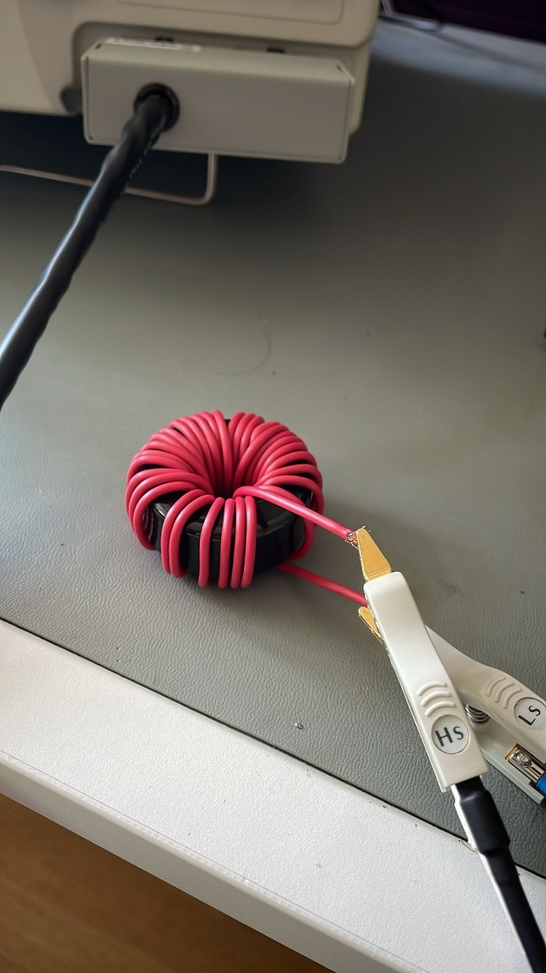

Figure X. Output inductor design and test setup

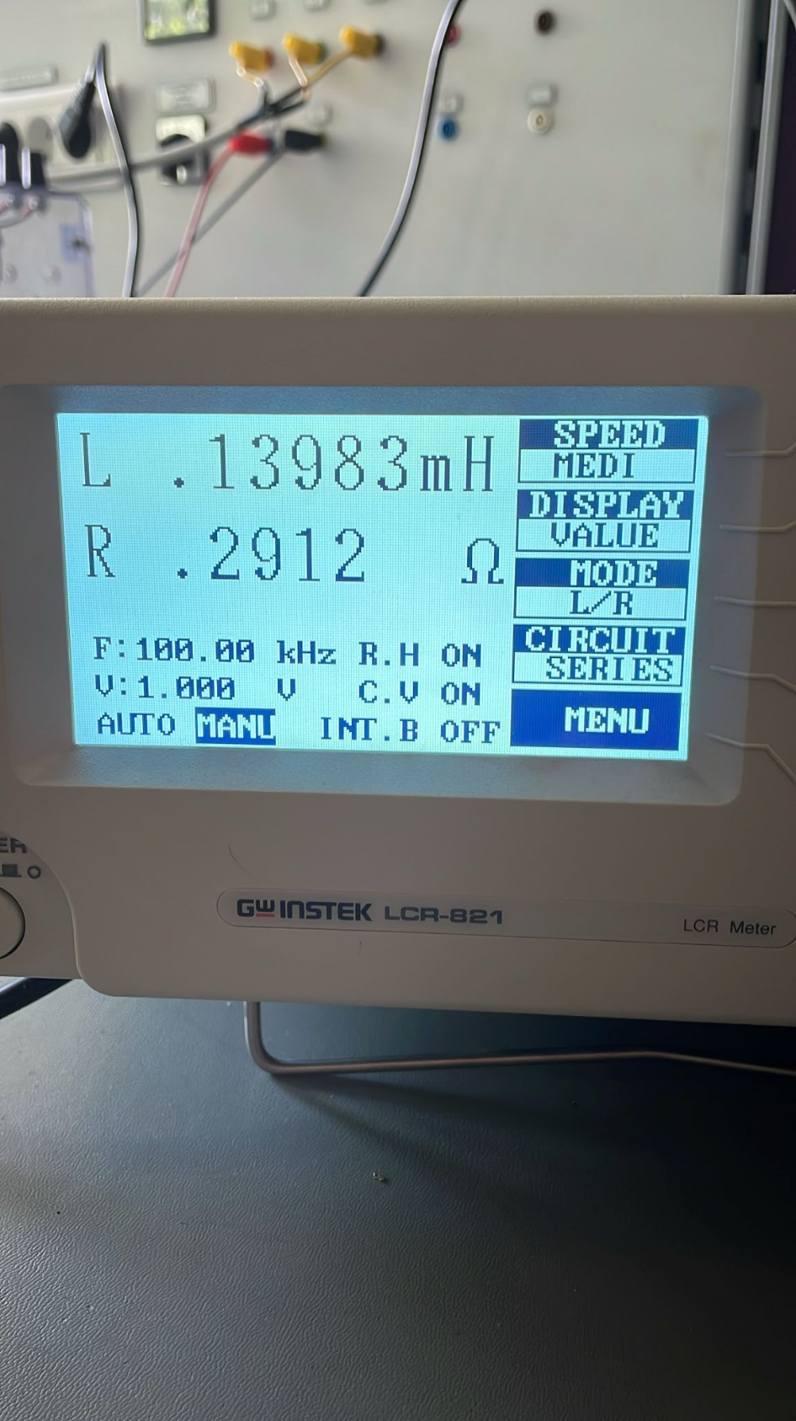

## Magnetizing and Leakage Inductance Tests

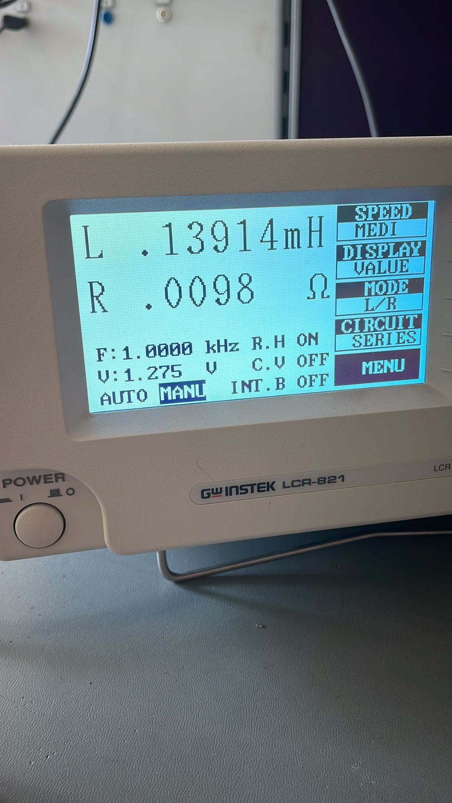

Şekil 1. From Primary side, Secondary open

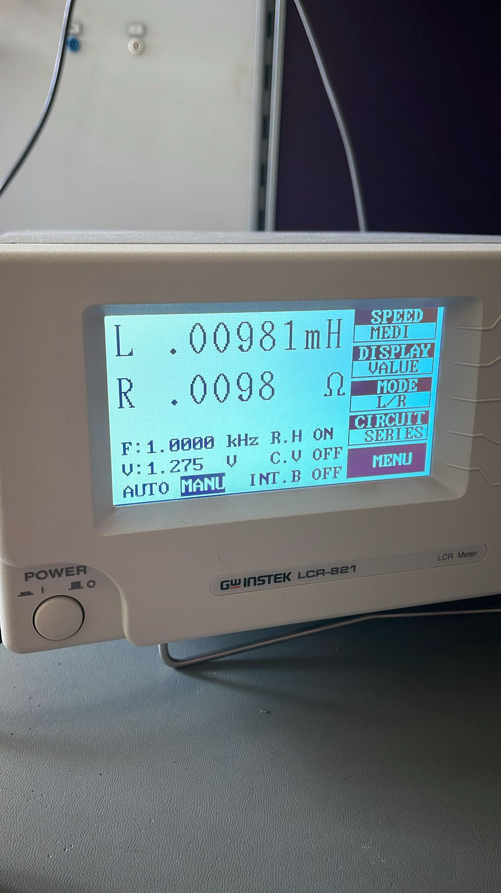

Şekil 2 From Primary side, Secondary shorted

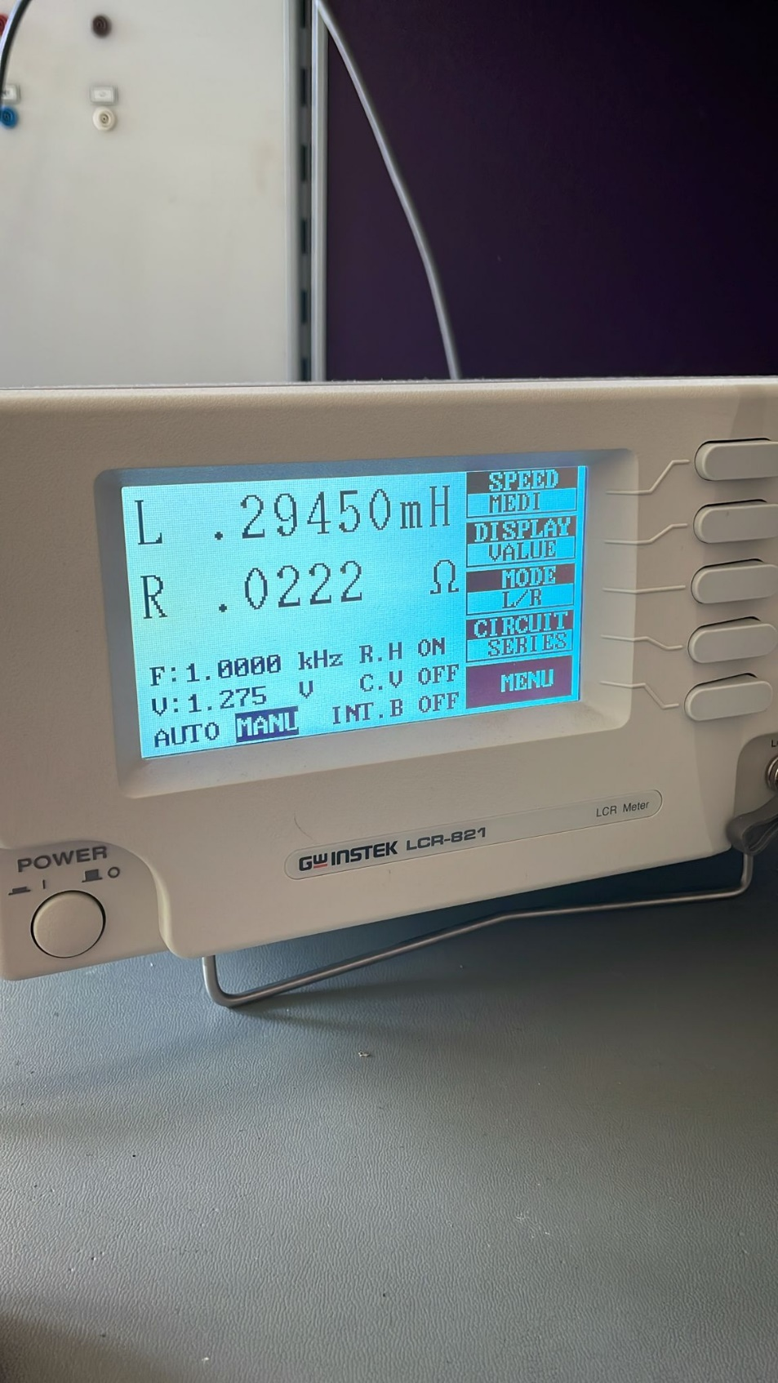

Şekil 3From Primary side, Secondary open

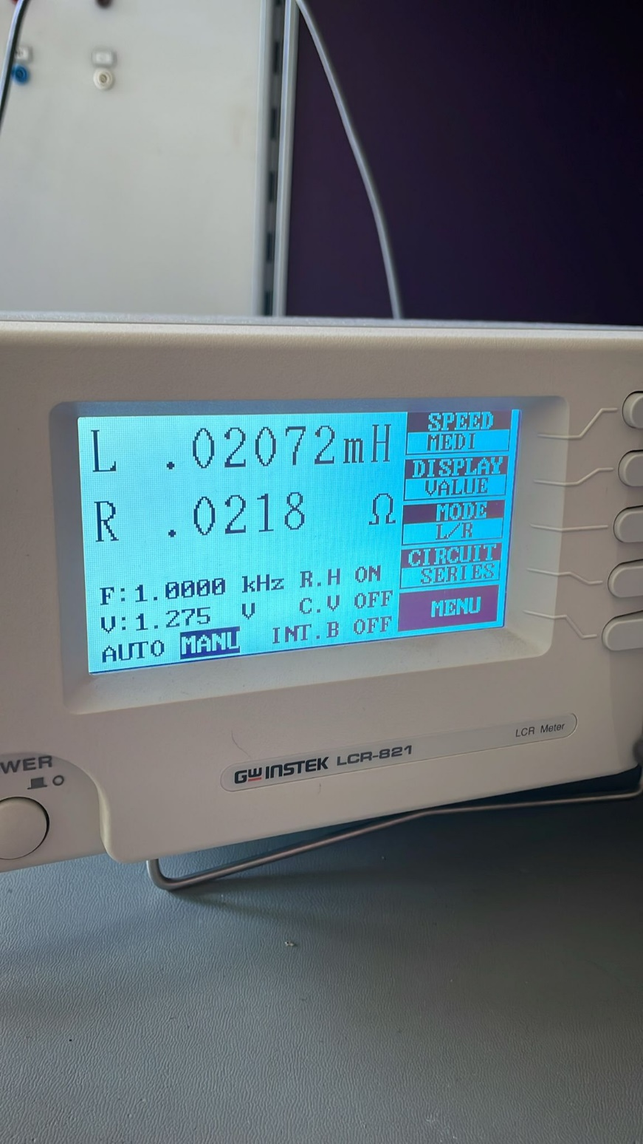

Şekil 4 dfg

# Closed Loop Controller

# Simulations

# Component Selection

## MOSFET

### GATE DRİVER

## DİODE

## OPTOCOUPLER

## WİRES

### LİTZ

### AWG

# Further Considerations

## Efficency

## Ripple

# Conclusion

In conclusion, for the specified project aiming to develop an efficient and open-source isolated DC-DC converter with a focus on achieving stable output voltage and high efficiency, the choice of topology is crucial. Given the project's requirements and objectives, the forward converter topology emerges as a suitable option due to its inherent advantages in efficiency, regulation, and suitability for higher power levels.

**Topology Selection: Forward Converter**

The forward converter topology offers several key advantages for this project:

Regulation: Forward converters typically provide better output voltage regulation across varying load conditions compared to alternative topologies like flyback converters.

Output Ripple: With careful design and control, forward converters can exhibit lower output voltage ripple, meeting the project's requirement of a peak-to-peak ripple of 3%.

**Future Work and Development:**

Optimization for Efficiency: Implement further optimization techniques such as soft-switching methods (e.g., resonant converters) to enhance efficiency and reduce switching losses.

Compact Design: Explore design strategies to achieve a more compact layout, potentially integrating components and optimizing the transformer and inductor designs for reduced size and weight. We will try to implement our design on PCB.

High Power Density: Investigate advanced packaging techniques and material selection to increase power density without compromising thermal management and reliability.

Closed-Loop Control: Develop and implement robust closed-loop control algorithms to ensure stable and accurate regulation under varying input voltage and load conditions. We will focus on the problem of going into saturation from based on the suggestions from the past. We will adress this sooner and try to solve it.

# References

1. <https://www.mouser.com/pdfdocs/2-10.pdf>